CPE301 – SPRING 2019

Design Assignment 6

Student Name: Carlos D. Zuniga

Student #: 2000783713

Student Email: zunigc2@unlv.nevada.edu

Primary Github address: [https://github.com/blassen/](https://github.com/blassen/Dessign%20Assignments/)

Directory: DA6

1. **COMPONENTS LIST AND CONNECTION BLOCK DIAGRAM w/ PINS**

List of Components used

Block diagram with pins used in the Atmega328P

MPU6050

1. **INITIAL/MODIFIED/DEVELOPED CODE OF TASK 1/A**

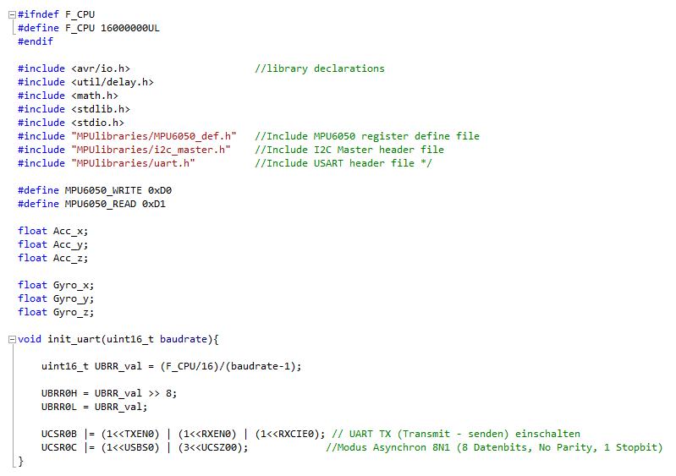

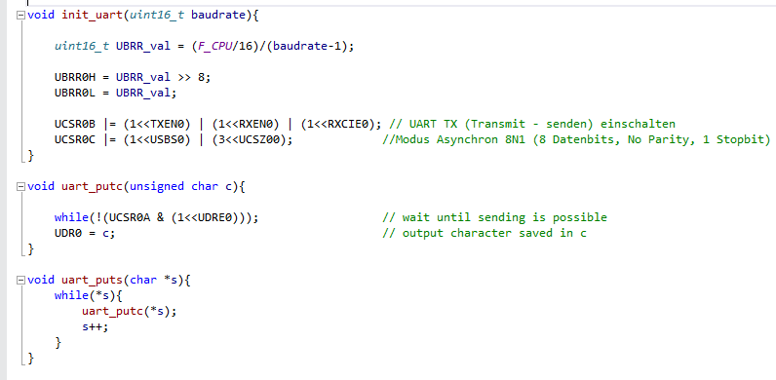

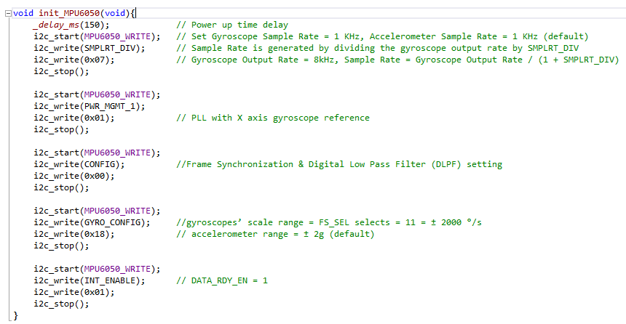

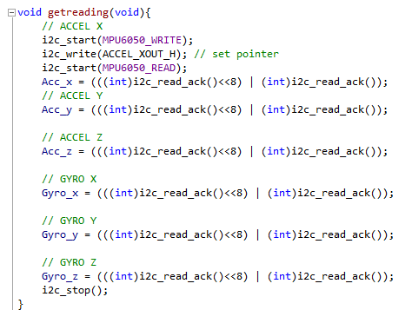

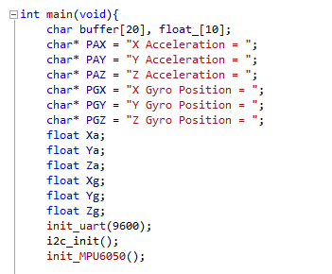

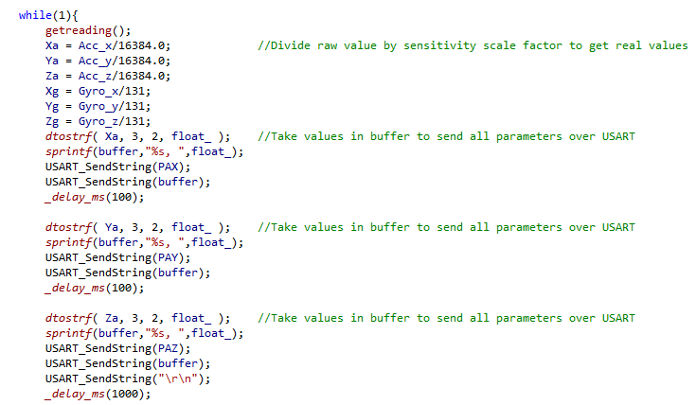

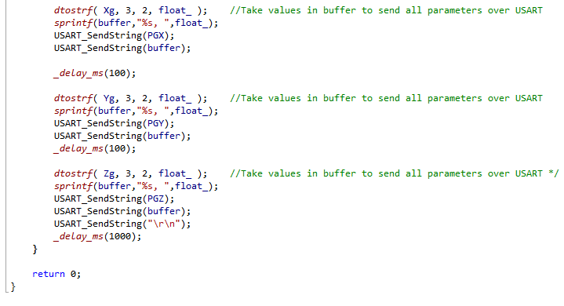

1. **SCHEMATICS**

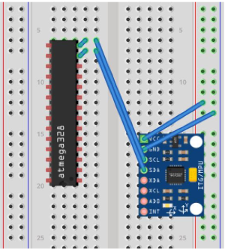

1. **SCREENSHOTS OF EACH TASK OUTPUT (ATMEL STUDIO OUTPUT)**

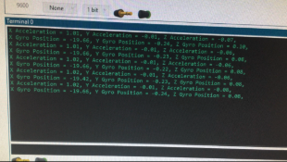

1. **SCREENSHOT OF EACH DEMO (BOARD SETUP)**

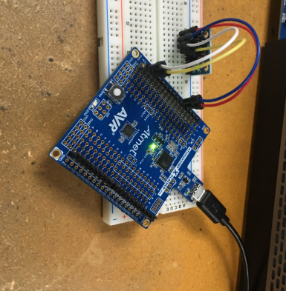

1. **VIDEO LINKS OF EACH DEMO**

<https://youtu.be/YRbFuB-GOMU>

1. **GITHUB LINK OF THIS DA**

**https://github.com/blassen**

**Student Academic Misconduct Policy**

<http://studentconduct.unlv.edu/misconduct/policy.html>

“This assignment submission is my own, original work”.